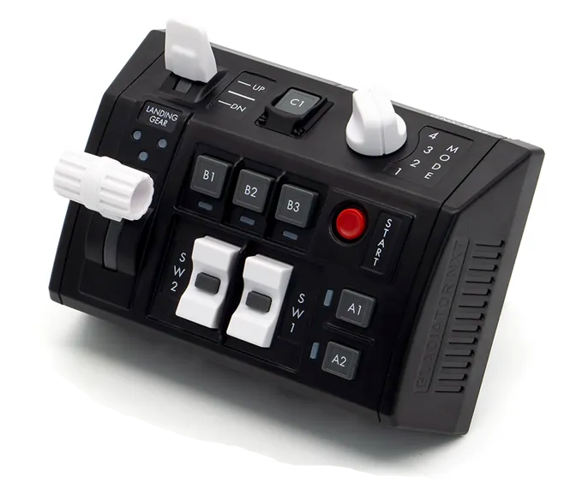
104 - Controls - GNX SEM-V
U=Up, D=Down, N=Neutral, F=Forward, B=Backward, L=Left, R=Right, P=Press, S-*=Shift-*, L-*=Long-*

Landing Gear
- U: Landing gear up
- N: --
- D: Landing gear down
Flaps Switch
- U: Flaps AUTO (up)
- N: Flaps HALF
- D: Flaps FULL
SW1 Rocker Switch
- U: Canopy open
- P: Canopy hold
- D: Canopy close
SW2 Rocker Switch
- U: Hook up
- P: Hook bypass toggle FIELD/CARRIER
- D: Hook down
- S-U: Fueling probe extend
- S-P: --
- S-D: Fueling probe retract
Start Button
- P: Jettison button
A1 Button
- P: Wing fold handle left
- S-P: Wing fold handle push
A2 Button
- P: Wing fold handle right
- S-P: Wing fold handle pull
B1 Button
- P: Toggle centerline station jettison select
B2 Button
- P: Selective jettison knob left
B3 Button
- P: Selective jettison knob right
C1 Button
- P: --
Mode Knob
- 1: --
- 2: --
- 3: --
- 4: --

